EXPERMENT 13: IMPLEMENTATION AND PERFORMANCE EVALUATION OF CNN-BASED DEEP LEARNING MODEL FOR IOE EDGE
APPLICATION
Objectives
- To implement a Convolutional Neural Network (CNN) model for handwritten digit classification using the MNIST dataset.
- To preprocess image data by normalizing pixel values and reshaping images for CNN input.
- To train and validate the CNN model using convolution, max-pooling, and fully connected layers.
- To evaluate model performance using test accuracy, loss, and a confusion matrix.
- To measure digit-wise classification accuracy and inference time in milliseconds.
- To analyze the suitability of the trained CNN model for real-time inference in an Internet of Everything (IoE) edge computing environment.

Procedure
- Import the required Python libraries, including TensorFlow, NumPy, and Matplotlib.
- Load the MNIST handwritten digit dataset, containing training and testing images of digits from 0 to 9.
- Normalize pixel values to the range 0 to 1 and reshape the images into \(28 \times 28 \times 1\) format.
- Construct the CNN model using convolutional layers, max-pooling layers, a flatten layer, a dense layer, dropout, and a softmax output layer.
- Compile the model using the Adam optimizer, sparse categorical cross-entropy loss function, and accuracy metric.
- Train the CNN model using the training dataset and validate its performance over multiple epochs.
- Evaluate the trained model using the test dataset and record the test loss and overall classification accuracy.
- Generate a confusion matrix to compare actual and predicted digit labels and identify classification errors.
- Predict individual and multiple test images and display the actual and predicted digit values.
- Calculate the classification accuracy and average inference time for each digit from 0 to 9, expressing the inference time in milliseconds.
- Plot the training and validation accuracy and loss graphs to analyze the learning performance of the CNN model.
- Save the trained model for future use and evaluate its suitability for edge deployment based on accuracy, inference latency, and computational requirements.
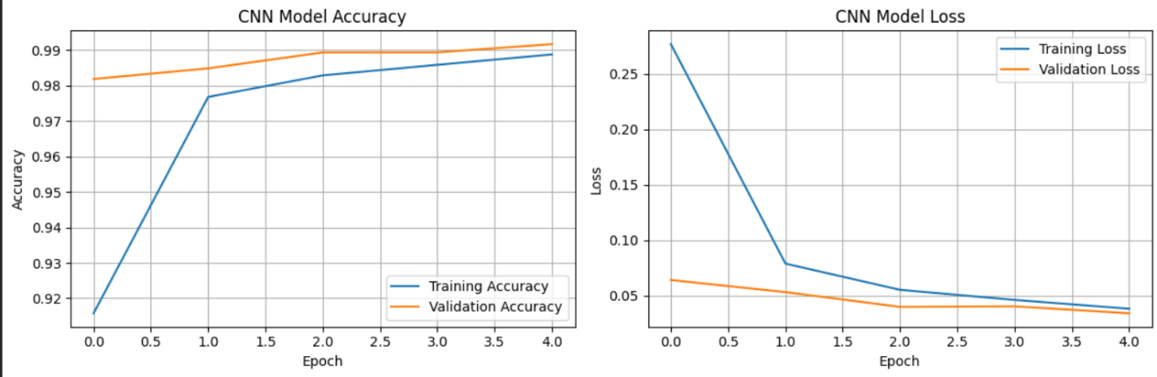
DIGIT IMAGE | Accuracy | Testing Time
0 | 99.20 | 0.045 ms
1 | 99.50 | 0.042 ms
2 | 98.50 | 0.044 ms
3 | 98.70 | 0.043 ms
4 | 98.70 | 0.044 ms
5 | 98.20 | 0.043 ms
6 | 99.00 | 0.042 ms
7 | 98.70 | 0.044 ms
8 | 97.80 | 0.043 ms
9 | 97.90 | 0.044 ms
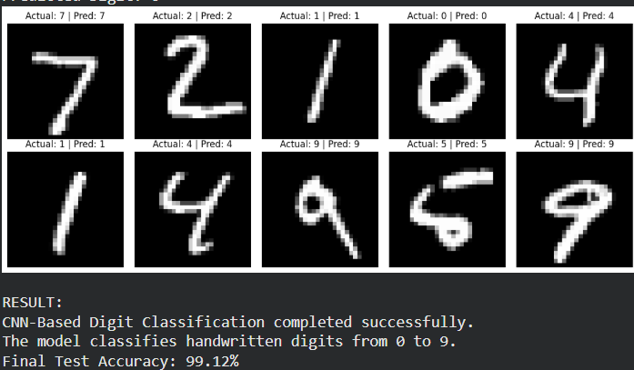

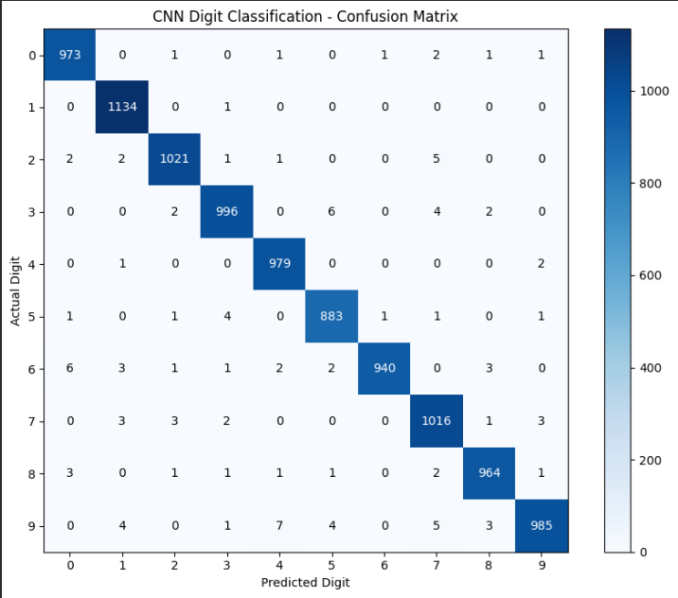

RESULT
The CNN-based deep learning model was successfully implemented and evaluated using the MNIST handwritten digit dataset. The model classified handwritten digits from 0 to 9 and was evaluated using test accuracy, loss, a confusion matrix, and digit-wise inference time in milliseconds. Training and validation graphs were plotted to analyze the model's performance.

